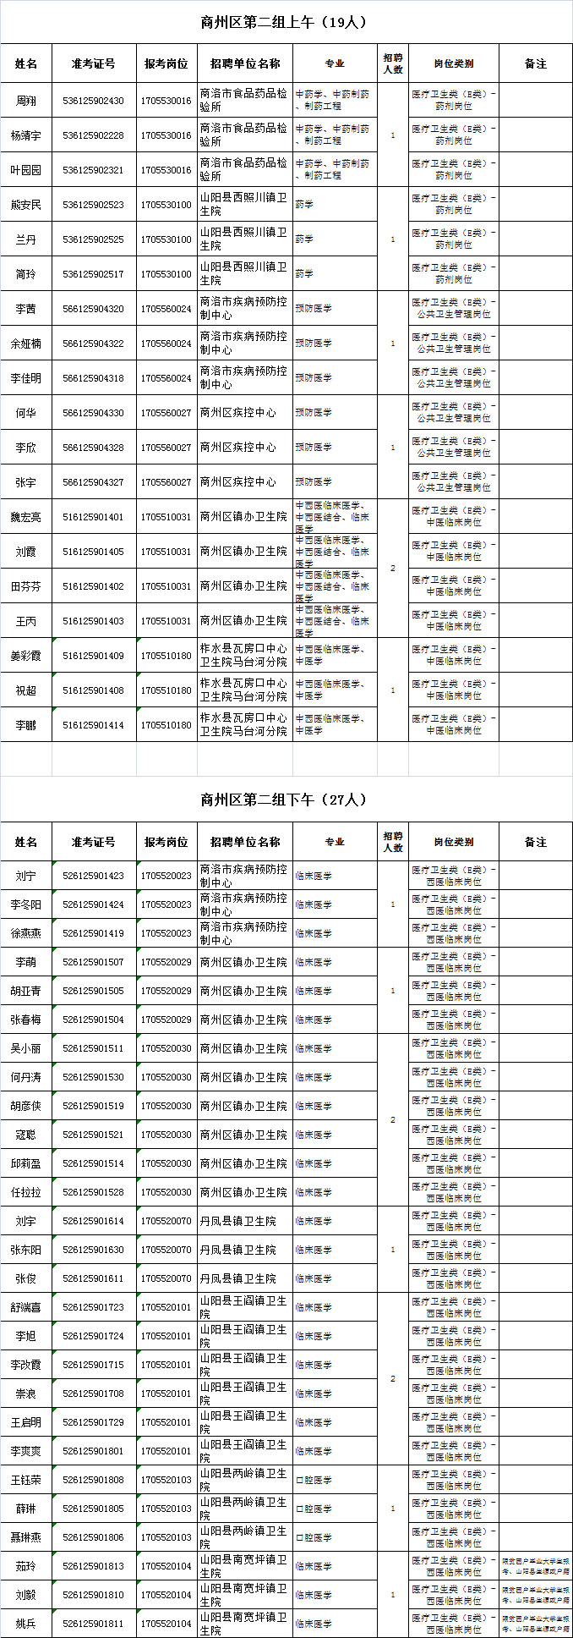  
[上一页](http://sa.offcn.com/html/2017/07/79111.html) [1](http://sa.offcn.com/html/2017/07/79111.html) 2 [3](http://sa.offcn.com/html/2017/07/79111_3.html) [4](http://sa.offcn.com/html/2017/07/79111_4.html) [5](http://sa.offcn.com/html/2017/07/79111_5.html) [6](http://sa.offcn.com/html/2017/07/79111_6.html) [7](http://sa.offcn.com/html/2017/07/79111_7.html) [8](http://sa.offcn.com/html/2017/07/79111_8.html) [9](http://sa.offcn.com/html/2017/07/79111_9.html) [10](http://sa.offcn.com/html/2017/07/79111_10.html) [11](http://sa.offcn.com/html/2017/07/79111_11.html) [推荐：](http://sa.offcn.com/html/2017/07/79111_3.html)[陕西事业单位招聘网](http://www.sdsgwy.com/html/shiyedanwei/)2017-07-25 09:17:29 | 商洛市人力资源和社会保障局   
